

Tribhuvan University

Faculty of Humanities and Social Sciences

**A PROJECT**-**II REPORT**

**ON**

**THE FASHION GALLERY**

**Submitted to:**

**Department of Computer Application**

**Jana Bhawana Campus**

***In partial fulfillment of the requirement for the Bachelors in Computer Application***

**Submitted by**

**Asha Silwal (TU Regd. No : 6-2-253-2-2019)**

**Puja Thapa (TU Regd. No : 6-2-253-8-2019)**

**Mangsir, 2080**

# SUPERVISORS RECOMMENDATION

I hereby recommend that this project is prepared under my supervision by **Asha Silwal** and **Puja Thapa** entitled **“THE FASHION GALLERY**” in partial fulfillment of the requirement for the degree of Bachelor of Computer Application be processed for the evaluation.

………………………..

**Mr. Bikram Bastola**

# LETTER OF APPROVAL

This is certified that this project is prepared by **Asha Silwal** and **Puja Thapa** entitled **“THE FASHION GALLERY”** in partial fulfillment of the requirements for degree of Bachelors of Computer Application (BCA) has been well studied. In our opinion it is satisfactory in the scope and quality as a project for the required degree.

|  |  |
| --- | --- |
| ………………………  **Signature**  **Mr. Bikram Bastola**  Supervisor  Jana Bhawana Campus  Godawari-11,Lalitpur | ………………………  **Signature**  **Mr. Santosh Adhikari**  Head of Department(BCA)  Jana Bhawana Campus  Godawari-11,Lalitpur |
| ………………….  **Signature**  **Internal Examiner** | ………………….  **Signature**  **External Examiner** |

# ACKNOWLEDGEMENT

We extend our heartfelt gratitude to the many individuals whose unwavering support and assistance made this project a reality. This endeavor would not have been possible without their kind contributions. We sincerely thank each and every one of them. It has been an immense honor and privilege to embark on this project, and we are profoundly grateful. We reserve a special expression of gratitude for our project head, **Er. Sushant Gautam**, whose constant supervision, guidance, and direction were pivotal to our success. His provision of crucial project information and his unwavering support throughout the project were truly invaluable. We also extend our thanks to our BCA coordinator, **Mr. Santosh Adhikari**, and our project supervisor, **Mr. Bikram Bastola**. Their guidance, motivation, encouragement, and continuous support played a pivotal role in helping us complete this project successfully. Our appreciation extends to our subject teachers for their support, encouragement, and unwavering guidance. Their willingness to share their extensive knowledge enriched our understanding of the project and its complexities, enabling us to meet our project deadlines. Additionally, we would like to express our profound gratitude to our parents, dear friends, and those who generously shared their abilities in the development of this project. Your contributions have been instrumental in our achievement.

# ABSTRACT

The name of this project is “The Fashion Gallery”. This system is web based application developed using PHP and MySQL following incremental model as a software process model. It is about offering customers a variety of fancy clothing items and accessories for different genders. The purpose of this system is to computerize the manual shopping system. This is the concept where customer can find what they are looking for and make their purchase easy with just few clicks. This system implements content-based filtering as recommendation algorithm based on product id and recommends same category products and linear search as searching algorithm. In other similar applications, there is trust issues because of product’s quality so, this project is supposed to gain trust by providing quality products and services to customers. Customers can give feedback through star rating to the products and services of this system that helps to improve and enhance the customer experience and allow to make strong bond with customers. There is payment integration system and delivery that makes customer feel more comfortable with online system. Here customers can shop from anywhere through using their devices without visiting store physically. There is also well management of large number of products. This system helps to enhance online transaction between seller and buyer. It promotes trendy clothing products to meet customer’s tastes and preferences. Overall, The Fashion Gallery is the perfect choice for customers looking for high-quality fancy clothing items and better shopping experience.

***Keywords* :** e-commerce, linear search, content-based, star rating and digital payment

TABLE OF CONTENTS

**ACKNOWLEDGEMENT i**

**ABSTRACT ii**

**LIST OF FIGURES v**

**LIST OF TABLES vi**

**LIST OF ABBREVIATION vii**

**CHAPTER 1: INTRODUCTION 1**

**1.1 Introduction 1**

**1.2 Problem Statement 2**

**1.3 Objectives 2**

**1.4 Scope and Limitation 3**

**1.4.1 Scope ...………………………………………………………………………….3**

**1.4.2 Limitation ...…………………………………………………………………….3**

**1.5 Development Methodology 3**

**1.6 Report Organization 5**

**CHAPTER 2: BACKGROUND STUDY AND LITERATURE REVIEW 6**

**2.1 Background Study 6**

**2.2 Literature Review 7**

**CHAPTER 3: SYSTEM ANALYSIS AND DESIGN 8**

**3.1 System Analysis 8**

**3.1.1 Requirement Analysis 8**

**3.1.2 System Requirement 10**

**3.1.3 Feasibility Analysis 11**

**3.1.4 Data Modeling(ER Diagram) 12****s**

**3.1.5 Process Modeling(System Flowchart) 14**

**3.1.6 Data Flow Diagram(DFD) 15**

**3.1.7 Block Diagram 17**

**3.2 System Design 18**

**3.2.1 Architectural Design 18**

**3.2.2 Database Schema Design 19**

**3.2.3 Interface Design 20**

**3.2.4 Physical DFD ………………………………………………………………….29**

**3.3 Algorithm Implementation 29**

**CHAPTER 4: IMPLEMENTATION AND TESTING 33**

**4.1 Implementation 33**

**4.1.1 Tools Used …………………………………………………………………….33**

**4.1.2 Implemented Modules 34**

**4.2 Testing 35**

**4.2.1 Unit Testing …………………………………………………………………...35**

**4.2.2 System Testing 38**

**CHAPTER 5: CONCLUSION AND FUTURE RECOMMENDATION 41**

**5.1 Conclusion 41**

**5.2 Lesson Learnt 41**

**5.3 Future Recommendations 42**

**REFERENCES 43**

**APPENDIX**

# LIST OF FIGURES

**FIGURE PAGE**

Figure 1.1 : Incremental Model…..………….….................................................4

Figure 3.1 : Use Case Diagram Of The Fashion Gallery………..………............9

Figure 3.2 : E-R Diagram Of The Fashion Gallery………..…………................13

Figure 3.3 : System Flowchart Of The Fashion Gallery………..……….............14

Figure 3.4 : Zero Level DFD Of The Fashion Gallery………..………...............15

Figure 3.5 : Level-1 DFD Of The Fashion Gallery………..…………................16

Figure 3.6 : Block Diagram of The Fashion Gallery………..………..................17

Figure 3.7 : Architectural Design Of The Fashion Gallery .................................18

Figure 3.8 : Database Schema Design Of The Fashion Gallery…….……..........19

Figure 3.9 : Physical DFD Of The Fashion Gallery ............................................29

Figure 3.10 : Flowchart Of Content-based Filtering On The Fashion Gallery.....30

Figure 3.11 : Flowchart Of Linear Search On The Fashion Gallery …...............32

# LIST OF TABLES

**TABLE PAGE**

Table 4.1 : Unit Testing For Admin Module………………………………....35

Table 4.2 : Unit Testing For User Module……………………………………37

Table 4.3 : System Testing For Admin Module………………………………38

Table 4.4 : System Testing For User Module………………………………...39

# LIST OF ABBREVIATION

CSS : Cascading Style Sheets

DBMS : Database Management System

DFD : Data Flow Diagram

ER Diagram : Entity Relationship Diagram

HTML : Hypertext Markup Language

PHP : Hypertext Preprocessor

RDMS : Relational Database Management System

SDLC : Software Development Life Cycle

SQL : Structured Query Language

# INTRODUCTION

## Introduction

The Fashion Gallery is an online clothing store that seeks to modernize the traditional manual shopping system. This system is developed using PHP and MySQL and following the incremental model as a software process model, this project aims to provide customers with a wide variety of fancy clothing items and accessories for different genders. It was designed to offer a better shopping experience for customers by simplifying the purchase process with just a few clicks. It is the platform to showcase varieties of products that attracts customers for shopping and visit this website.

To address the challenges that customers often face in traditional shopping systems, The Fashion Gallery provides content-based filtering and search functionalities. By using this application, customers can easily find the products they want without visiting store to store physically. Additionally, the project implements a recommendation algorithm based on customer purchase and search history, allowing customers to discover new clothing items that match their style. This system focuses on customer’s satisfaction and trust and makes shopping more enjoyable.

The Fashion Gallery ensures that customers have a better shopping experience by providing a payment integration system and delivery methods that they can trust. This system allows customers to shop from anywhere using their devices without having to visit a physical store. By providing quality products and services, The Fashion Gallery seeks to gain customer trust. Furthermore, The Fashion Gallery values customer feedback. There is review section on this system where customers can share their opinions about the products and services. This feature helps to build trust and allows The Fashion Gallery to improve and enhance the customer experience.

The management of a large number of products is well-organized, which enhances online transactions between the seller and the buyer. The project is an innovative online store that offers customers a convenient, safe, and better shopping experience. Overall, The Fashion Gallery is a great option for customers who are looking for high-quality and trendy clothing products that meet their tastes and preferences.

## Problem Statement

The traditional shopping system has several challenges, including the need to physically visit multiple stores to find the desired product, limited product options, and the lack of a reliable payment and delivery system. This system can be time-consuming and expensive for customers. There is no any history of customers to know their interest for offering recommendations of products. There are several existing online clothing stores, but many of them still face challenges such as poor website design, limited product options, unreliable payment and delivery systems, and poor customer service. These issues can lead to a lack of trust in online shopping and dissatisfied customers. Therefore, this system is introduced to address these challenges and provide a better shopping experience for customers.

## Objectives

1. To implement an e-commerce platform with secure user authentication and authorization features.
2. To Offer content-based filtering for recommendation and linear search functionality.
3. To Offer online payment that enhances convenience, providing efficient shopping experience for our customers.
4. To implement user-friendly rating system for products within to gather customer feedback.

## Scope and Limitation

### Scope

1. The Fashion Gallery broadens access to a diverse range of fashion products, attracting a global customer base.
2. It provides a platform for fashion designers, manufacturers, and retailers to showcase and sell their products worldwide.
3. The system's advanced technology enhances the shopping experience by simplifying product discovery and recommendations.
4. With a focus on quality, trust, and customer satisfaction, The Fashion Gallery aims to revolutionize online fashion retailing.

### Limitation

1. Global shipping constraints
2. Inconvenient in returns and refunds
3. Not compatible with all types of digital devices

## Development Methodology

The project follows an Incremental Model, breaking it into manageable segments. It's ideal for small projects with evolving requirements, allowing changes as needed. The process involves customer communication, planning, implementation, testing, and evaluation in cycles. This adaptability permits flexibility, accommodating user demands by incorporating changes and additional features gradually. The approach is well-structured, focusing on simplicity and responsiveness to evolving project needs. In this model process phases are separated as requirements, design, code and testing which we can clearly see in diagram given below.

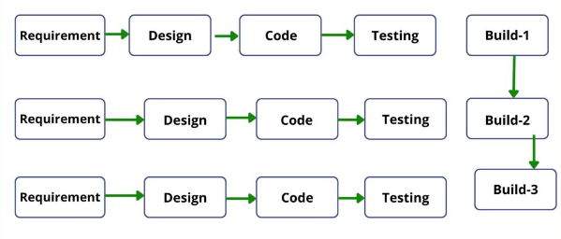

**Figure 1.1 : Incremental Model [9]**

[source : <https://sampletestcases.com/incremental-model/>]

As per the above figure 1.1, in this model, incrementally adding piece by piece expect that each piece is completed. So, Each iteration has requirements, design, coding, and testing phases.

* **Requirements Analysis :**

In this phase, the experts gather the requirements from the customers and analyze them. Requirements documents such as SRS (Software Requirement Specification), BRS(Business Requirements Specification), and CRS(Customer Requirement Specification).

* **Design :**

In this phase, the main focus is on the design of the system functionality with high-level and low-level designs.

* **Coding :**

In the coding phase of the model, the development team implements the functionality and passes it to the next phase.

* **Testing :**

When testing team receives the builds from development team, software test engineers test each and every functionality of the system and verify it as per the requirements.

## Report Organization

This project report contains five chapters.

* First Chapter : This chapter explain about introduction of the project that contains the description of project, problem statement, objective, scope and limitation, and development methodology.
* Second Chapter : This chapter explain about background study about project and literature review that contains researches done by others on similar to this project.
* Third Chapter : This chapter contains all the system analysis and design related parts. It includes requirement analysis, feasibility analysis, different diagrams related to the system, interface design etc.
* Fourth Chapter : This chapter discuss on implementation process and testing of system. It includes tools used for the project and unit and system testing.
* Fifth Chapter : This chapter is the final chapter of this report that discuss about conclusion and future recommendation. It includes closure of this project and the improvements that can be done in future.

# BACKGROUND STUDY AND LITERATURE REVIEW

## Background Study

The Fashion Gallery project emerges from the need to revolutionize traditional manual shopping through an online clothing store. With the use of PHP and MySQL and following the incremental model, the project focuses on providing a diverse range of fancy clothing items and accessories for various genders, aiming for a seamless and enjoyable shopping experience. The emphasis is on simplifying the purchase process and showcasing a variety of products to attract and engage customers.

In addressing challenges faced in traditional shopping systems, The Fashion Gallery incorporates content-based filtering and search functionalities. By leveraging a recommendation algorithm based on product id that helps to recommend same category products, the system helps customers discover new clothing items that match their style preferences. This approach centers on customer satisfaction, trust-building, and overall enjoyment in the shopping process.

To ensure a superior shopping experience, The Fashion Gallery integrates a reliable payment system and trustworthy delivery methods. This allows customers to shop conveniently from anywhere using their devices, eliminating the need to visit a physical store. Customer feedback is valued, with a dedicated review section encouraging opinions about products and services. This feedback loop contributes to building trust and continuous improvement in enhancing the customer experience.

The well-organized management of a large number of products enhances online transactions between sellers and buyers. The project positions itself as an innovative online store, offering customers a convenient, safe, and improved shopping experience. The focus on high-quality and trendy clothing products aims to meet the diverse tastes and preferences of customers in the competitive online fashion market. Overall, The Fashion Gallery stands as a promising option for those seeking a modernized and satisfying online shopping venture.

## Literature Review

A study conducted by Kim and Kim (2017), customer satisfaction is positively related to customer loyalty, which in turn leads to increased sales and profits for the company. Therefore, it is essential for the fashion gallery to focus on customer satisfaction. [3]

A study conducted by Soni and Vashishtha (2020), quality is the most critical factor in customer satisfaction. The fashion gallery can ensure high quality by carefully selecting their suppliers and performing quality checks on all products. [4]

A study conducted by Pazzani and Billsus (2007), Content-based filtering recommends items by analyzing their features and matching them with user preferences. [5]

A study conducted by A. R. Mohanty et al., linear search algorithm was used to extract relevant features from images for image classification purposes. The authors found that linear search was effective in identifying and extracting important features from images.[6]

A study by MetaPack found that 96% of fashion retailers offer free delivery for orders over a certain amount (MetaPack, 2020). This indicates that The Fashion Gallery's delivery methods are in line with industry standards.[7]

A study conducted by Sharma et al. (2021) shows that mobile payment integration enhances customer experience, increases sales, and improves customer loyalty. The study also highlights the cost-saving benefits for fashion retailers as mobile payments reduce the need for physical payment systems. [8]

# SYSTEM ANALYSIS AND DESIGN

## System Analysis

It includes system’s requirement and its analysis.

### Requirement Analysis

It includes two types of requirements. They are :

#### Functional Requirement

* Account creation, login, and logout functionality.
* Profile updating for users.
* Password changing feature.
* Adding, updating, and removing fashion products for administrators.
* User-friendly search feature.
* Attractive display of fashion products with high-quality images.
* Adding products to the cart and completing purchases for users.
* View and manage orders for administrators.
* Users can provide feedback and reviews for products.

##### **Use Case Diagram**

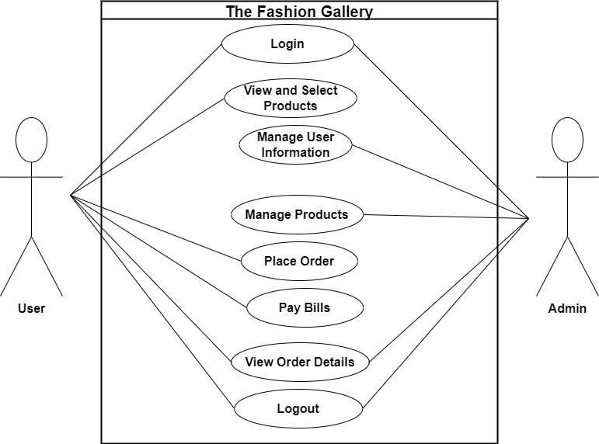

**Figure 3.1 : Use Case Diagram Of The Fashion Gallery**

In the above figure 3.1, there are two actors: user and admin. They first login to this system and then user can view and select products, place order, pay bills, view order details and logout. Likewise admin can manage user information, manage products, view order details and logout.

#### Non-Functional Requirement

* Scalability : The system is designed to handle potential growth in data and user interactions. As the number of fashion products and users increases, the system can efficiently scale to accommodate the growing demands without compromising performance.
* Portability : The system is portable and can be easily transferred or deployed across different environments. Whether hosted locally or on a web server, it maintains consistency and functionality, ensuring users can access it seamlessly from various devices.
* Reliability : The system is reliable, ensuring consistent performance and availability. Users can depend on the system for secure and efficient access to fashion products, and administrators can rely on it for accurate and timely updates to the product database.
* Backup and Recovery : Regular database backups are implemented to safeguard against data loss. In the event of an unexpected incident, the system has a robust recovery mechanism in place, ensuring minimal disruption and quick restoration of data.
* Response Time : The system exhibits fast response times, providing users with a quick and seamless experience. Whether searching for fashion products or updating details, users can expect rapid system responsiveness, contributing to an efficient and satisfactory user experience.

### System Requirement

It includes the system software and hardware requirements.

#### Software Requirement

In this phase, it can include the requirement of software for this project. It needs:

##### **Development Requirement**

To develop a good web application, there must be good gathering and analysis of requirements. A good collection of requirements increase the quality of system. The requirements are:

* Server: Xampp
* Toolkit: Visual Studio Code
* Coding Language: PHP, HTML, CSS, JavaScript

##### **Deployment Requirement**

The requirements which are necessary to develop our projects are :

* Operating System : Windows 10 or above/ Linux/ Mac

#### Hardware Requirement

* Hard Disk: Minimum 250 MB of free space.
* RAM: At least 512 MB.
* Screen Resolution: 1024x768.
* Processor: Intel P4 or latest

### Feasibility Analysis

It includes cost, functionality and technical analysis on this basis it checks the project is feasible or not.

Three key considerations involved in the feasibility analysis are:

#### Economic Feasibility

This study is carried out to check the economic impact that the system will have on the organization. The amount of fund that the organization can pour into the research and development of the system is limited. The expenditure is just for computational power. No other expenses are required to perform this project because most of the technologies used for this project are available freely. Thus, the proposed system is economically feasible.

#### Operational Feasibility

This study is carried out to check the level of acceptance of the system by the system. This includes the process of training needed by user to use the system efficiently. The project is user friendly; anyone can easily access to the data. There is no need of extra effort for users to use this system. This system proposed to make user familiar to this system easily, just entering information to the system. Thus, the proposed system is operationally feasible.

#### Technical Feasibility

This study is carried out to check the technical feasibility, that is the technical requirements of the system. Any system developed must not have a high demand on the available technical resources. This will lead to high demands being placed on the client. This developed system must have a modest requirement as only minimal or null changes are required for implementing this system. Thus, the proposed system is technically feasible

### Data Modeling(ER Diagram)

In this phase we discuss about the design and development of data model for storing data in database. Data modeling provides visual representation of data or information related to user. This phase is just for representing conceptual expression between data objects.

#### E-R Diagram (Entity Relationship Diagram)

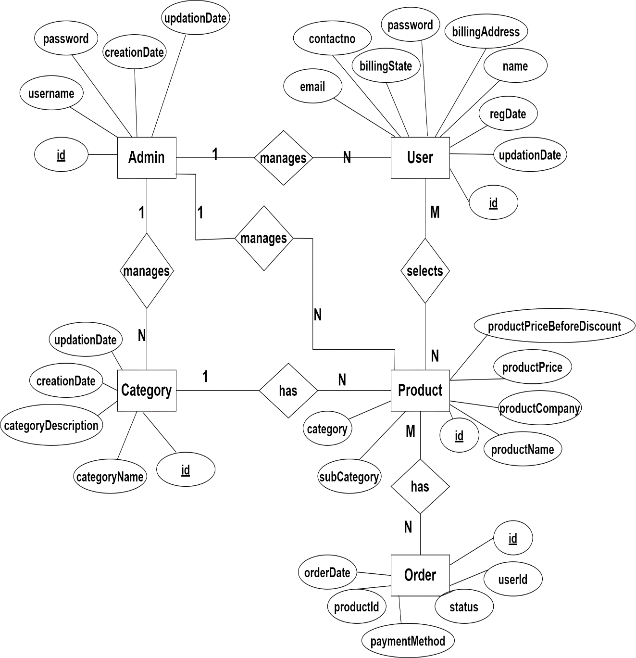

**Figure 3.2 : E-R Diagram Of The Fashion Gallery**

In this above diagram 3.2, there is relationship between admin, user, product, category and order entity. There are attributes for each entities. There is id which is written in underlined form that represents id is primary key for each entities. And user id is foreign key for entity order. User can manage products and product have order and have category. Likewise admin can manage products, users and category. These entities are linked with other.

### Process Modeling(System Flowchart)

#### System Flowchart

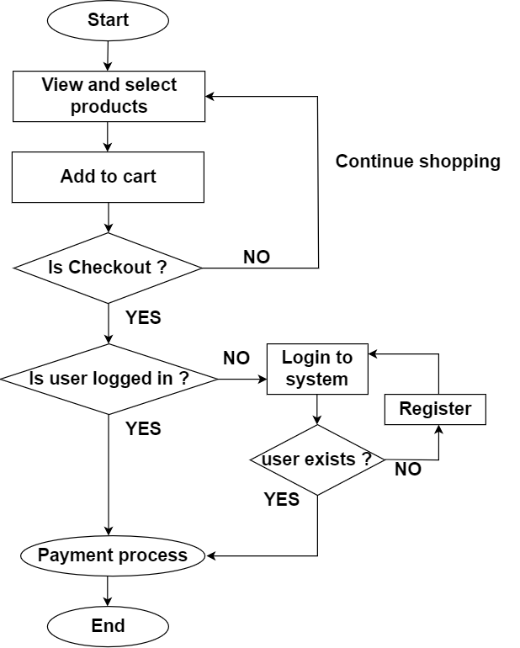

**Figure 3.3 : System Flowchart Of The Fashion Gallery**

In this above figure 3.3, it shows that there is flow of system processing. Firstly user start the process by selecting products that they add to cart to purchase, totaling is done. If ok user further go for checkout else it returns back to continue shopping. Further it checks for user existence, if yes then goes for login else it goes for registration and at last payment process is done and process is ended.

### Data Flow Diagram(DFD)

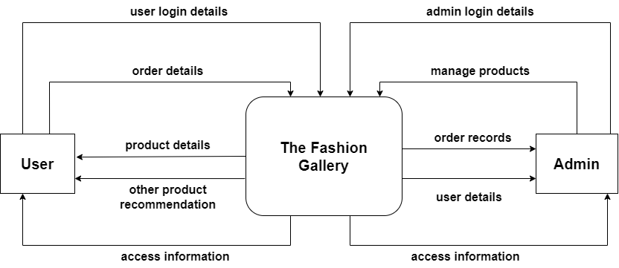

**Figure 3.4 : Zero Level DFD Of The Fashion Gallery**

In this above figure 3.4, user enters input as login details and order details and system response back with product details, other product recommendations and errors if any. And admin also gives input as login details, product lists and system returns output as order records, user details and errors if any occur.

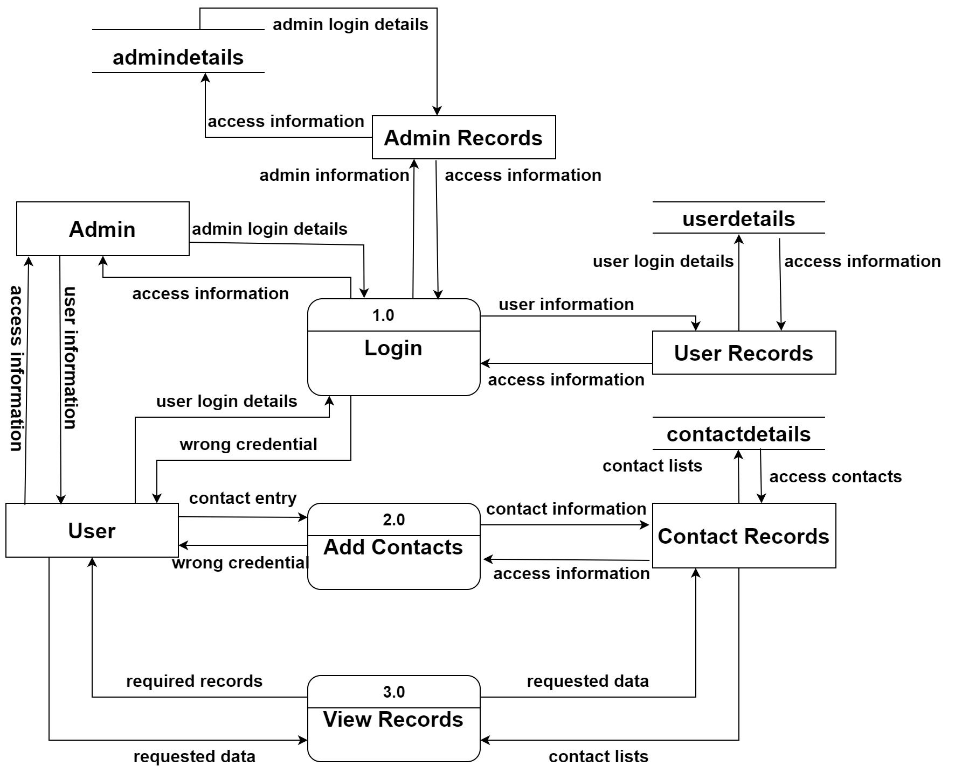

**Figure 3.5 : Level-1 DFD Of The Fashion Gallery**

### Block Diagram

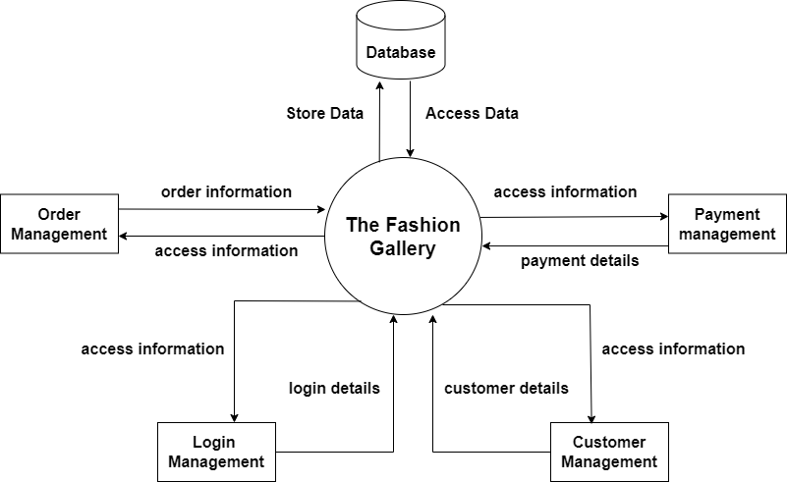

**Figure 3.6 : Block Diagram Of The Fashion Gallery**

From the above figure 3.6, it represents that how login management, order management, payment management and customer management are connected to this system. And how this department inputs data and system stores it to database and how system retrieve data through database whenever needed.

## System Design

It includes design of this project.

### Architectural Design

It shows the structure and organization of the software, outlining how different components will work together to achieve the desired functionality.

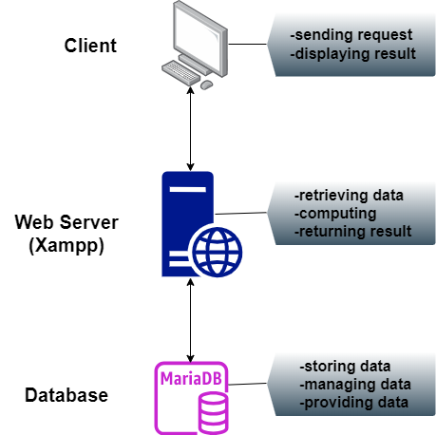

**Figure 3.7 : Architectural Design Of The Fashion Gallery**

### Database Schema Design

It shows the table created with its columns in database.

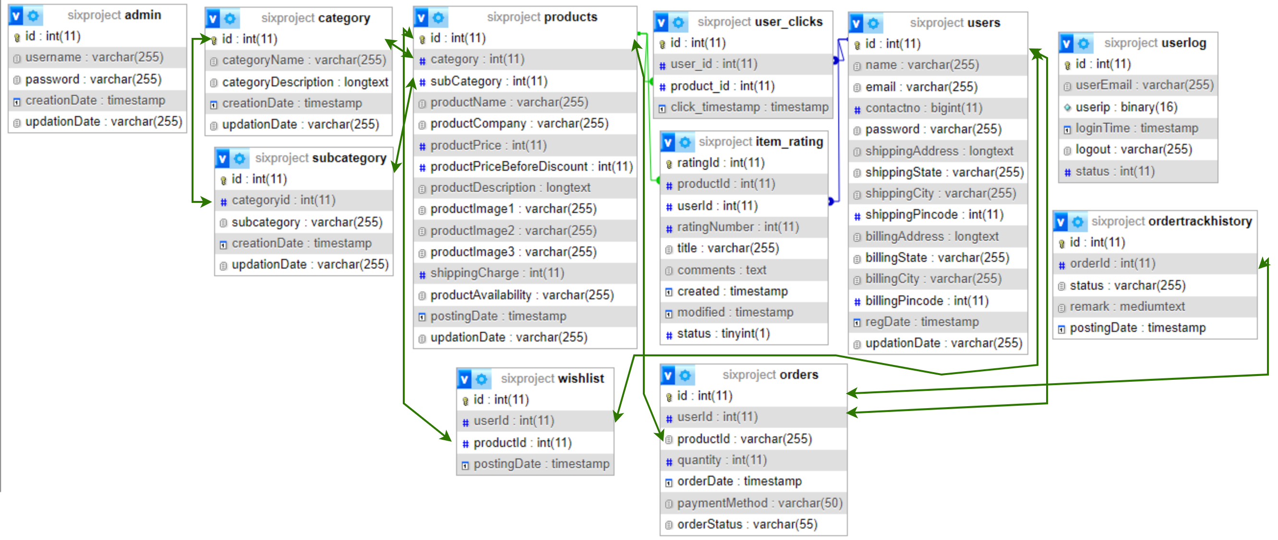

**Figure 3.8 : Database Schema Design Of The Fashion Gallery**

### Interface Design

#### User Page

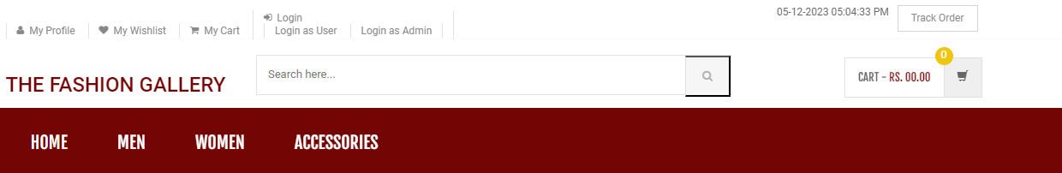

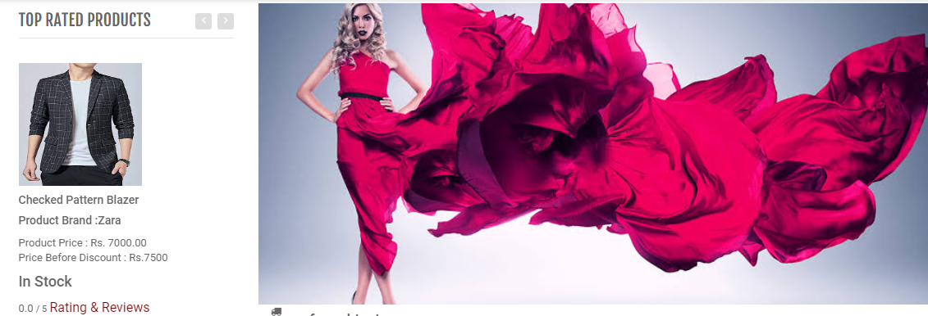

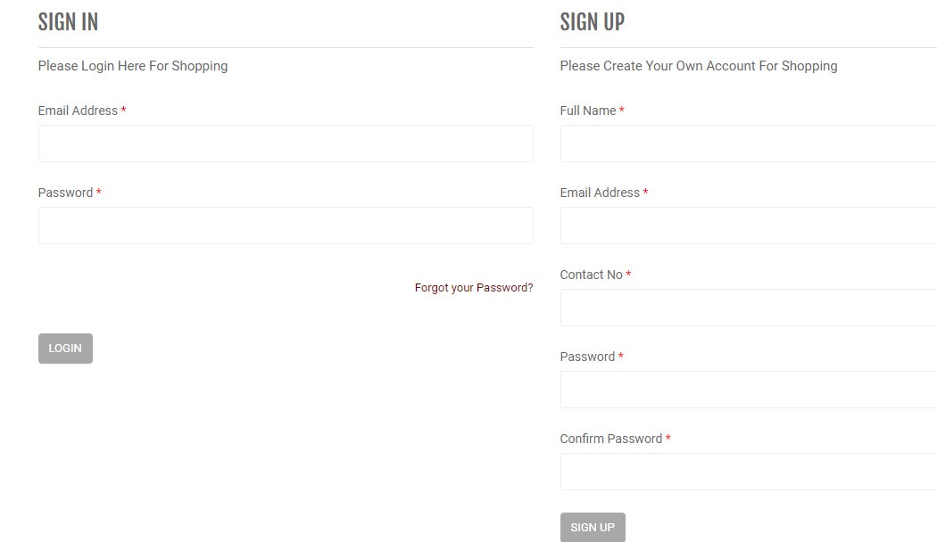

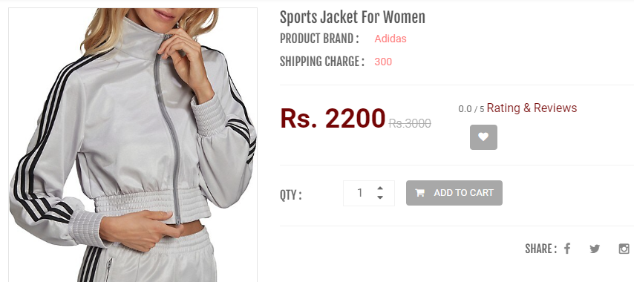

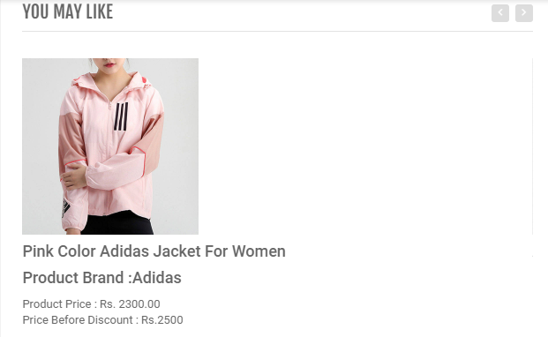

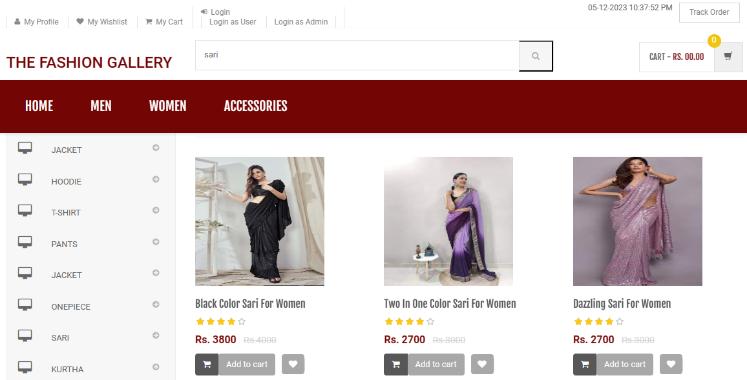

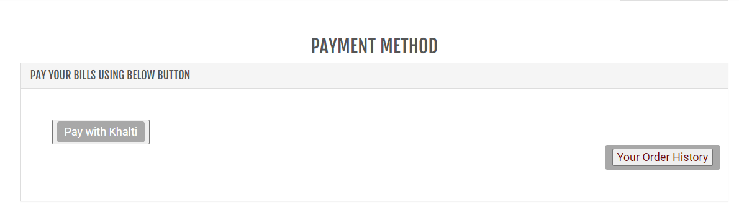

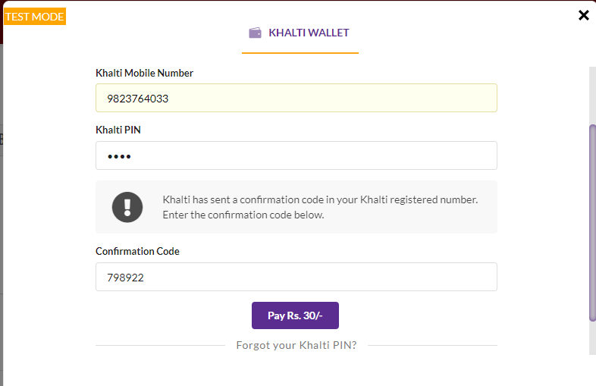

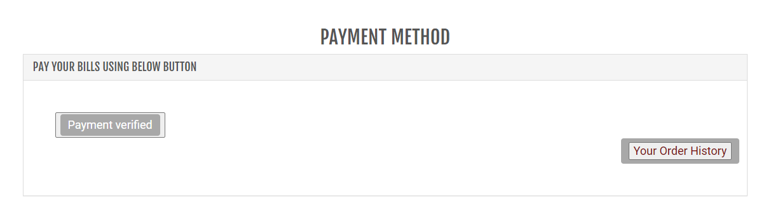

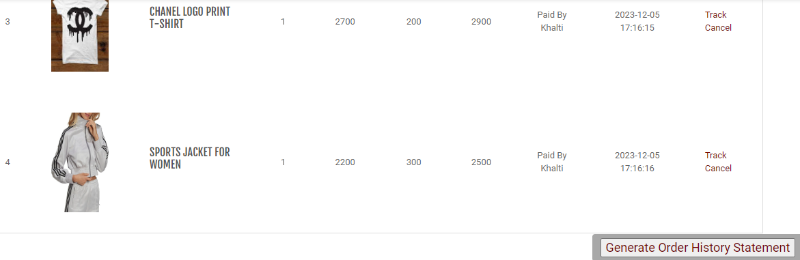

#### Admin Page

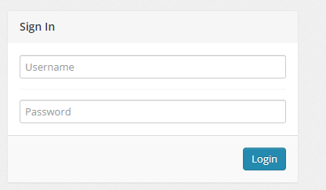

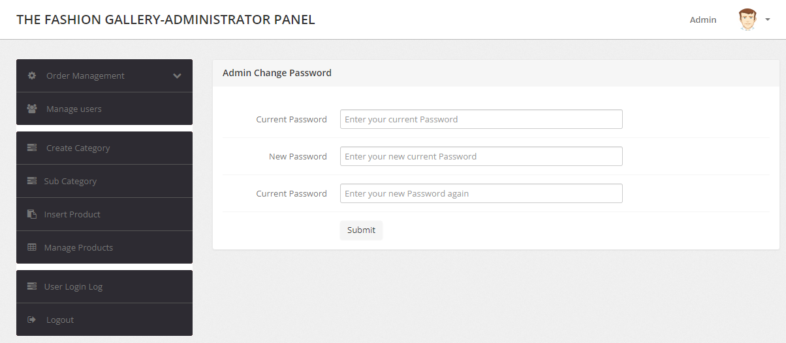

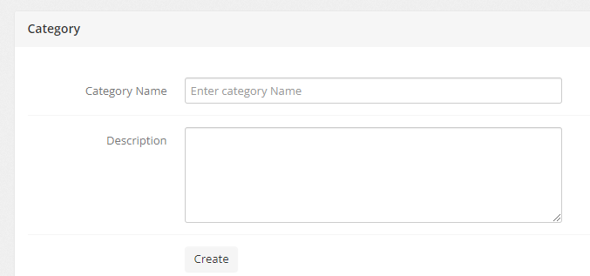

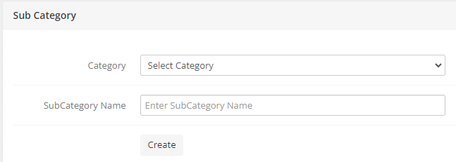

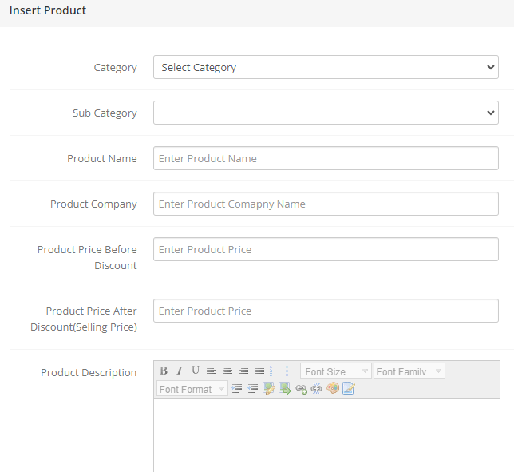

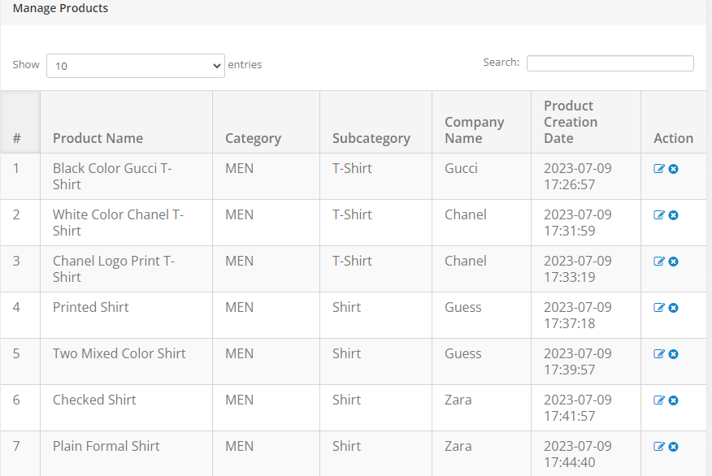

### Physical DFD

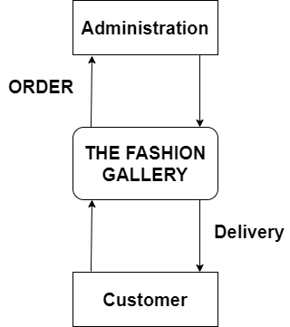

**Figure 3.9 : Physical DFD Of The Fashion Gallery**

## Algorithm Implementation

#### Content-based Filtering

Content-based filtering in The Fashion Gallery that take into account the category and subcategory information extracted from clicked products' URLs. This approach involves creating detailed profiles for each item, specifying attributes like category and subcategory. When a user interacts with a particular product, the system identifies the category and subcategory from the URL and associates it with the user's preferences. By analyzing these associations, the system recommends other items with similar category and subcategory attributes. This method ensures that recommendations offering a personalized and relevant shopping experience based on the specific fashion categories and subcategories the user has shown an inclination towards.

Steps :

1. Start the process.
2. Firstly user clicks to view product details from the dashboard.
3. And then gets product id which was clicked by user to see product details.
4. Further it checks for product id that is found or not. If found then display product details else get product id again.
5. When product details are displayed, it further checks the category and subcategory information of product that was clicked and displayed.
6. If it gets the information of category and subcategory of that clicked product then it recommends the similar products related to those category and subcategory else display no recommendation message.
7. At last end the process.

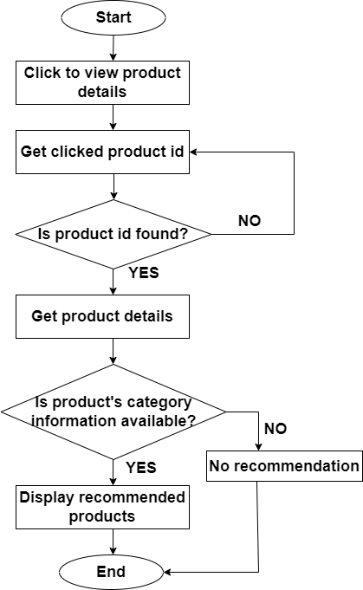

**Figure 3.10 : Flowchart Of Content-based Filtering On The Fashion Gallery**

In above figure 3.10, firstly user clicked to product to view products then gets product id that shows product details and then checks for the category and subcategory for the product id that is shown in url if found category and subcategory information then it displays recommended products otherwise shows no recommendation message.

#### Linear Search

Linear search is a pragmatic choice in the context of this system when there's a need to find specific clothing items. Similar to browsing through items one by one, linear search is straightforward and easy to implement. It proves valuable in scenarios where the list of fashion products is small or unsorted, making it effective for quickly locating a target item without any prior information about the organization of the data. Its simplicity makes it a suitable option for practical use when dealing with modest-sized or unordered lists in the system.

Steps :

1. Start the process.
2. Firstly enter product in search box.
3. And then searching process starts.
4. It compares the entered product with first position where the product is listed.
5. If product matched it displays product to user else compares with next position where next product is listed.
6. And the searching process repeated until the product gets matched. At the end of list if matched then displays product in screen else throws product not found message.
7. At last end the process.

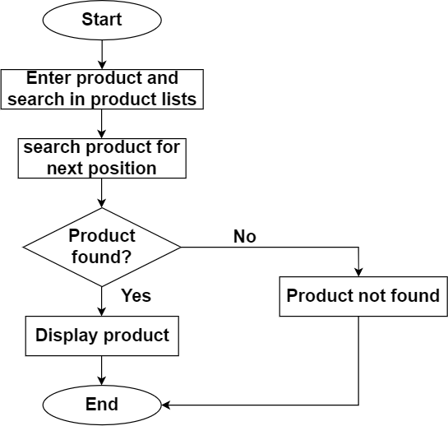

**Figure 3.11 : Flowchart Of Linear Search On The Fashion Gallery**

In above figure 3.11, firstly search for given product with first product if found terminated else goes for next position to search and process continuous until the given product is found.

# IMPLEMENTATION AND TESTING

## Implementation

It involves translating the design and planning into a functional system.

### Tools Used

* Visual Studio Code : Utilized for coding to develop and edit the source code of the Web-Based Book Store System, providing a streamlined development environment.
* XAMPP : Enabled local host and server connectivity, facilitating interactions with the MySQL database during both development and testing phases.
* phpMyAdmin : Employed for efficient database manipulation, allowing easy management and administration of the MySQL database associated with the Web-Based Book Store System.
* Technologies and Languages:
* Visual Studio Code (HTML) : HTML was used for creating and enhancing the structure of web pages, contributing to a clear and organized system layout.
* CSS3 : Implemented for styling web pages, offering a unified design approach across the entire system in an easily maintainable manner.
* PHP : Acted as the server-side object-oriented programming language, supporting the development of dynamic features and functionalities in the Web-Based Book Store System.
* MySQL : Served as the database management system, facilitating the storage and retrieval of data for the application.
* JavaScript : Applied for client-side scripting, particularly in the form validation process, enabling dynamic changes to system components.
* JQuery : Used to enhance the development process of JavaScript and implement various effects on web pages within the Web-Based Book Store System.
* Bootstrap : It is a free framework to streamline web development, providing design templates based on HTML and CSS. Bootstrap ensured a scalable and efficient application with a single code base, simplifying frontend development.

### Implemented Modules

**Customer Module :**

* Customer Account Management : Manage customer accounts securely, allowing them to register, log in, and update their information.
* Product Browsing and Selection : Enable customers to explore and choose from a diverse range of clothing items and accessories.
* Shopping Cart and Checkout : Facilitate the easy selection and accumulation of desired items, providing a smooth checkout process for a seamless shopping experience.
* Search Functionality : Implement a quick and efficient search feature for customers to find specific products easily.
* Content-based Filtering : Enhance the shopping experience by recommending items based on categories and subcategories, aligning with customer preferences.
* Payment Processing : Integrate a secure online payment system to ensure safe and efficient transactions for customers.
* Customer Review : Allow customers to share their reviews on products and services, fostering engagement and improvement.

**Admin Module:**

* Customer Access Control : Manage access levels and permissions for administrators to control system functionalities.
* Product Catalogue Management : Organize and update the product catalogue, ensuring accurate and timely information on available items.
* Order and Transaction Monitoring : Track and manage customer orders and transactions for effective order fulfillment.
* Inventory Management : Efficiently organize and monitor the inventory, ensuring product availability and managing stock levels.
* Customer Feedback Analysis : Analyze customer reviews and feedback to gather insights and make informed decisions for service and product improvements.
* Security and Authentication : Implement and maintain robust security measures to protect user data and the integrity of the e-commerce platform.
* System Maintenance and Updates : Ensure the smooth operation of the system by performing regular maintenance and implementing necessary updates.

## Testing

### Unit Testing

**Table 4.1 Unit Testing For Admin Module**

|  |  |  |  |  |  |
| --- | --- | --- | --- | --- | --- |
| **S.N.** | **Test Case** | | | **Expected Output** | **Remarks** |
| **1.** | Sign In | i. | Sign In with valid email and password | Login successfully !! Redirect admin to admin’s index page | Test successful |
| ii. | Sign In with invalid email or password | Login failed !! Alert message for valid input insertion | Test successful |
| iii. | Sign In with empty email and password | Login failed !! Alert message for empty email and password input | Test successful |
| **2.** | Add Product | i. | Add a product with valid details | Product added successfully | Test successful |
| ii. | Add a product with missing required fields | Error : Please fill all required fields Alert message for missing fields | Test successful |
| **3.** | View Product | i. | View product details with existing product ID | Display product details | Test successful |
| ii. | View product details with non-existing product ID | Error : Product not found Alert message for non-existing product | Test successful |
| **4.** | Update Product | i. | Update product details with valid information successfully | Product details updated | Test successful |
| ii. | Update product details with missing information | Please fill all required fields Alert message for missing fields | Test successful |
| **5.** | Delete Product | i. | Delete product with valid product ID | Product deleted successfully | Test successful |
| ii. | Delete product with invalid product ID | Error : product deletion failed !! | Test successful |

**Table 4.2 : Unit Testing For User Module**

|  |  |  |  |
| --- | --- | --- | --- |
| **S.N** | **Test Case** | **Expected Output** | **Remarks** |
| **1.** | Sign In with valid email and password | Login successfully !!  Redirect user to index page | Test successful |
| **2.** | Sign In with invalid email or password | Login failed !!  Alert message for valid input insertion | Test successful |
| **3.** | Sign Up with unique email and valid password | Account created successfully | Test successful |
| **4.** | Sign Up with already registered email | Error : Email already in use | Test successful |
| **5.** | Update user profile with valid information | Profile updated successfully | Test successful |
| **6.** | Update user profile with invalid user ID | Error: User ID not found | Test successful |

### System Testing

**Table 4.3 : System Testing For Admin Module**

|  |  |  |  |  |
| --- | --- | --- | --- | --- |
| **S.N** | **Test Case** | **Description** | **Expected Output** | **Remarks** |
| **1.** | Sign In | Enter valid login details for admin | Redirect to admin’s index page | Test successful |
| **2.** | Product Insertion | Fill all the fields in insertion with product details | Insertion successful !! Product should be inserted to database | Test successful |
| **3.** | Product Update | Enter details that should be changed | Changed successful !! Changes should be saved to database | Test successful |
| **4.** | Product Search | Enter letters or name | Products that matched search letter or name should be displayed to screen | Test successful |
| **5.** | Product Delete | Click cross sign to delete product | Product should be deleted from database | Test successful |
| **7.** | Product Category Create and Update | Create category of product and change category according to need | Product category should be inserted in database and update changes | Test successful |
| **8.** | Product Subcategory Create and Update | Choose category and name subcategory of product and change subcategory according to need | Product subcategory should be inserted in database and update changes | Test successful |
| **9.** | View User Lists | Select manage users | All user lists should be viewed to admin | Test successful |
| **10.** | View Order Lists | Select order management | All order lists should be viewed to admin | Test successful |

**Table 4.4 : System Testing For User Module**

|  |  |  |  |  |
| --- | --- | --- | --- | --- |
| **S.N.** | **Test Case** | **Description** | **Expected Outcome** | **Remarks** |
| **1.** | Sign In | Enter valid email and password | Login Successful !!! Redirect to index page | Test successful |
| **2.** | Categories list | Choose any category listed | Product lists should be displayed on the basis of category | Test successful |
| **3.** | My Wishlist | Show wish lists only if login to system | All wish list should be displayed | Test successful |
| **4.** | My Profile | Show the details of user | All details of user should be displayed | Test successful |
| **5.** | Track Order | Track the order by giving order id and email | Redirect to track-order page | Test successful |
| **6.** | Add to cart | Add products to cart for purchasing | If login to system then goes for checkout else redirect to login page | Test successful |
| **7.** | Checkout | Pay bill | Redirect to payment method for purchasing | Test successful |
| **8.** | Your Order History | Display all the order history of user | All the order history should be displayed | Test successful |
|  | | | | |

# CONCLUSION AND FUTURE RECOMMENDATION

## Conclusion

The "Fashion Gallery" project is like a super-smart helper that we've created and tested to make managing a fashion store easy and fun. We made sure it's efficient and easy to use, with a nice look on the computer or phone. After checking what's great about it and where it could do a bit better, we can say it does what people need. Think of the Fashion Gallery like a tool that can work with different systems without any problem. If we use it in fashion stores, it can save a bunch of time by doing things like entering data super quickly and making useful reports right away.

Switching from doing everything by hand to using this smart system is a big step for running a Fashion Gallery. This system helps us keep a really good eye on all the clothes and accessories, and we can make reports whenever we want. It also makes everyone in the store more responsible. We promise to keep making the system even better and safer. When we imagine using the Fashion Gallery in all sorts of fashion stores, we're pretty sure it will change the usual way of doing things and make managing fashion products much, much better.

## Lesson Learnt

Creating The Fashion Gallery taught us that building a tool that's easy to use and efficient is key. We learned to listen to users' needs, making sure the product meets their requirements. The flexibility of The Fashion Gallery became clear, showing it can fit into different systems, especially in fashion stores where it saves time and generates useful reports. Shifting from manual to automated processes was a big improvement, helping us keep a close eye on products and making our organization more responsible. We're committed to ongoing improvements and safety measures to make The Fashion Gallery even better. Looking ahead, we see it revolutionizing how fashion products are managed, making things simpler and more effective.

## Future Recommendations

For future recommendations, consider the followings :

* Enhanced Features : Continuously add new features to The Fashion Gallery to keep up with evolving trends and customer expectations. This could include innovative search functionalities, personalized user experiences, or integration with emerging technologies.
* Mobile App Development : Create a mobile application for The Fashion Gallery to expand its accessibility. Many users prefer shopping on their mobile devices, and a dedicated app could enhance the overall user experience.
* Integration with Social Media : Incorporate social media integration to allow users to share their favourite fashion finds easily. This can enhance the platform's visibility and attract more users.
* Expand Product Range : Continuously expand and diversify the range of products available on The Fashion Gallery. Collaborate with a variety of designers and brands to offer users a broader selection.
* Enhanced Security Measures : Invest in advanced security measures to protect user data and ensure a safe shopping environment. This is crucial for building and maintaining customer trust.

# REFERENCES

1. S. Singh, R. Saud, and I. Chaudhary, "Database Management System," KEC Publication and Distribution Pvt. Ltd, 2076.
2. R. Saud, S. Singh, S. B. Singh, and I. Chaudhary, "System Analysis and Design," KEC Publication and Distribution Pvt. Ltd, 2076.
3. H. J. Kim and Y. K. Kim, "Customer satisfaction and loyalty in the fast fashion business," Journal of Fashion Marketing and Management, vol. 21, no. 3, pp. 340-353, 2017.
4. S. Soni and P. Vashishtha, "Factors affecting customer satisfaction in the Indian apparel retail industry: An empirical study," Journal of Fashion Marketing and Management, vol. 24, no. 1, pp. 74-91, 2020.
5. M. J. Pazzani and D. Billsus, "Content-Based Recommendation Systems," in The Adaptive Web, pp. 325-341, Springer, 2007.
6. A. R. Mohanty, S. K. Rath, and A. K. Baliarsingh, "Feature Extraction Using Linear Search Algorithm for Image Classification," Journal of Multimedia, vol. 6, no. 4, pp. 423-430, 2011.
7. MetaPack, "The 2020 state of e-commerce delivery," 2020.
8. S. Sharma, M. S. Singh, and Y. K. Dwivedi, "Analysis of Consumer Adoption of Artificial Intelligence in Service Encounters," Journal of Service Research, vol. 24, no. 1, pp. 23-40, 2021.
9. "Incremental Model."

# APPENDIX

#### User Page





















#### Admin Page











